**Approach1: Bluemix Deployment using Delivery Pipeline**

**Prerequisites:**

* Bluemix Space should be created and developer access should be in place for the Account that will used for deployments

Refer below document for steps to create and configure tool chnain and Delivery pipeline for one of the service.



Login to Bluemix Oraganization (watson) & space (afpva) and open the toolchain (afpva-toochain).

This will have the Delivery piplelines created for all AFPVA services and can be manully triggered for downloading code from inner source ,building and deploy the application.

We need to make few chnages for below services before deploying them on any new space

|  |  |  |
| --- | --- | --- |
| **afpva-agent-dashboard** | **Config.js**  Holds the configuration end points for Bot config service (**afpva-botconfig-services**), Action Handler Lookup (**afpva-actionhandlerlookup-service**) and Form template service (**afpva-formtemplate-service**) | All these URLS needs to be replaced with setup specific URLs and deploy |
| **afpva-va-controller-service** | **application.yml**  This file holds property for referring Bot config service ([afpva-botconfig-services](https://innersource.accenture.com/projects/AFPVA/repos/afpva-botconfig-services/browse)) | This URL needs to replace with setup specific Bot Config URL |
| **afpva-va-dialog-service** | **application.yml**  This file holds the configuration for Bot config URL and Directory,Chtichat Conversation Service credentials Details | This URL needs to replace with HTTP version of setup specific Bot Config URL  Modify Directory,Chtichat Conversation Service credentials Details if needed and deploy |
| **afpva-client** | **Socket_connector.js**  Holds Connector service URL | Update this with setup specific connector service URL and deploy |
|  |  |  |

*Note: Delivery pipleines are not enabled for auto trigger.Developer has to manually trigger the pipeline, whenever there is change in service and needs deployment****.***

**Approach2: Bluemix Deployment using Eclipse**

**Prerequisites:**

* Bluemix Space should be created and developer access should be in place for the Account that will used for deployments
* Download AFPVA projects from innersource and import into Eclipse Workspace
* IBM Eclipse Tools for Bluemix installed
* Cloud foundry installed on machine for running CF commands

**Steps for Deployment:**

**[Disclaimer:** Steps mentioned below do not cover steps to enable continuous build and deploy. If any modification done, then it has to be manually built and deployed on Bluemix.]

This is section will mention stesp for deploying one service on provided Bluemix Space and same process should be followed for deploying all other services

**Step 1:** Download project module from Inner source (Use File -> import -> Git ( Projects from Git) -> Clone URI option)

**Step 2:** Build Project and generate war file

(1) Perform maven Clean of your project and follow below for steps for doing it

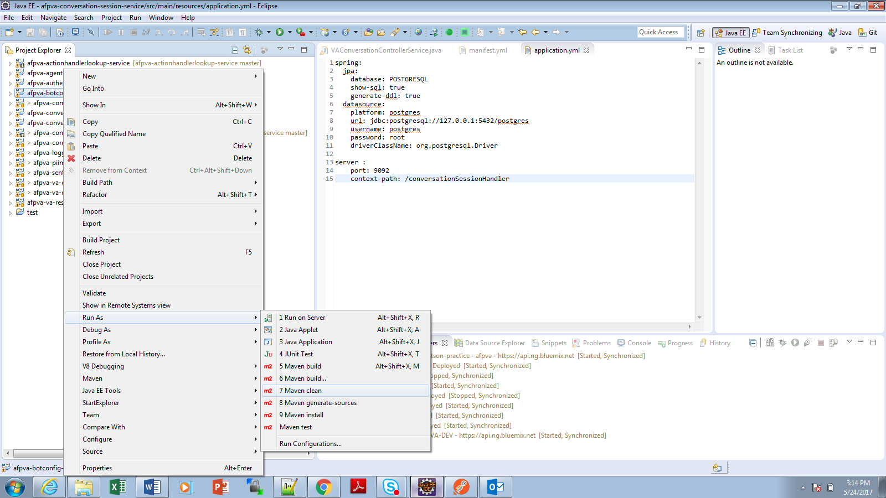

(2) Perform Project Build as shown below

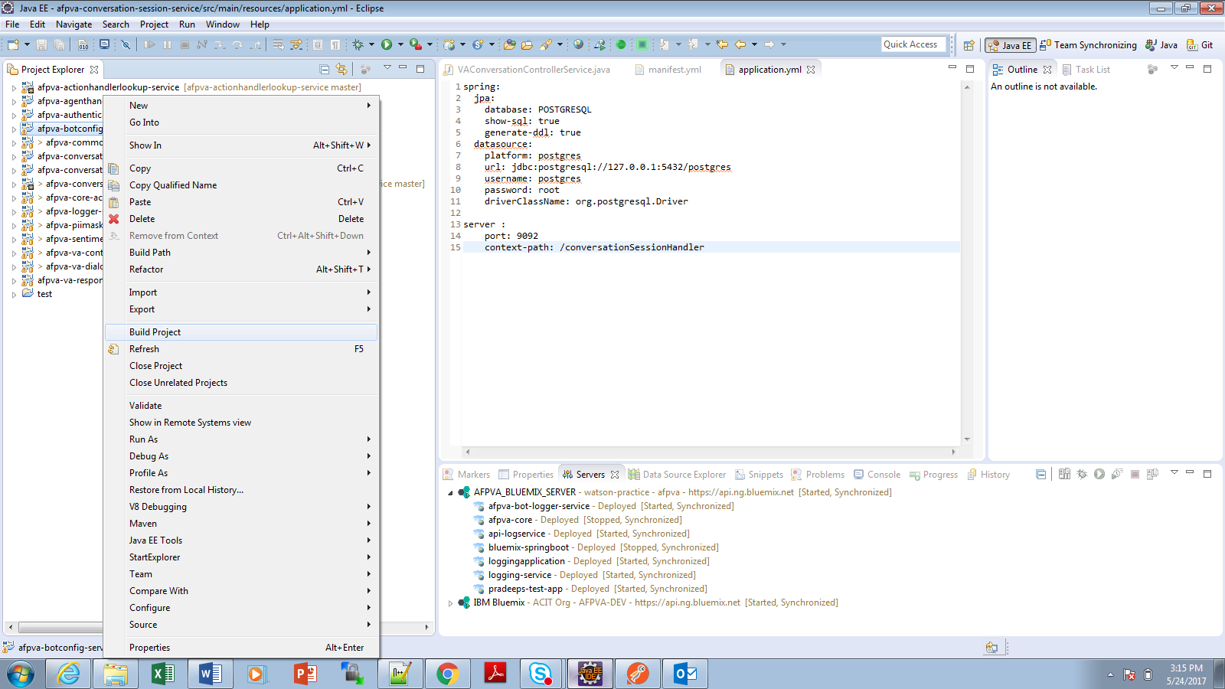

(3) Perform Maven package to create project war file

Right click on Project -> Run As -> Run Configurations

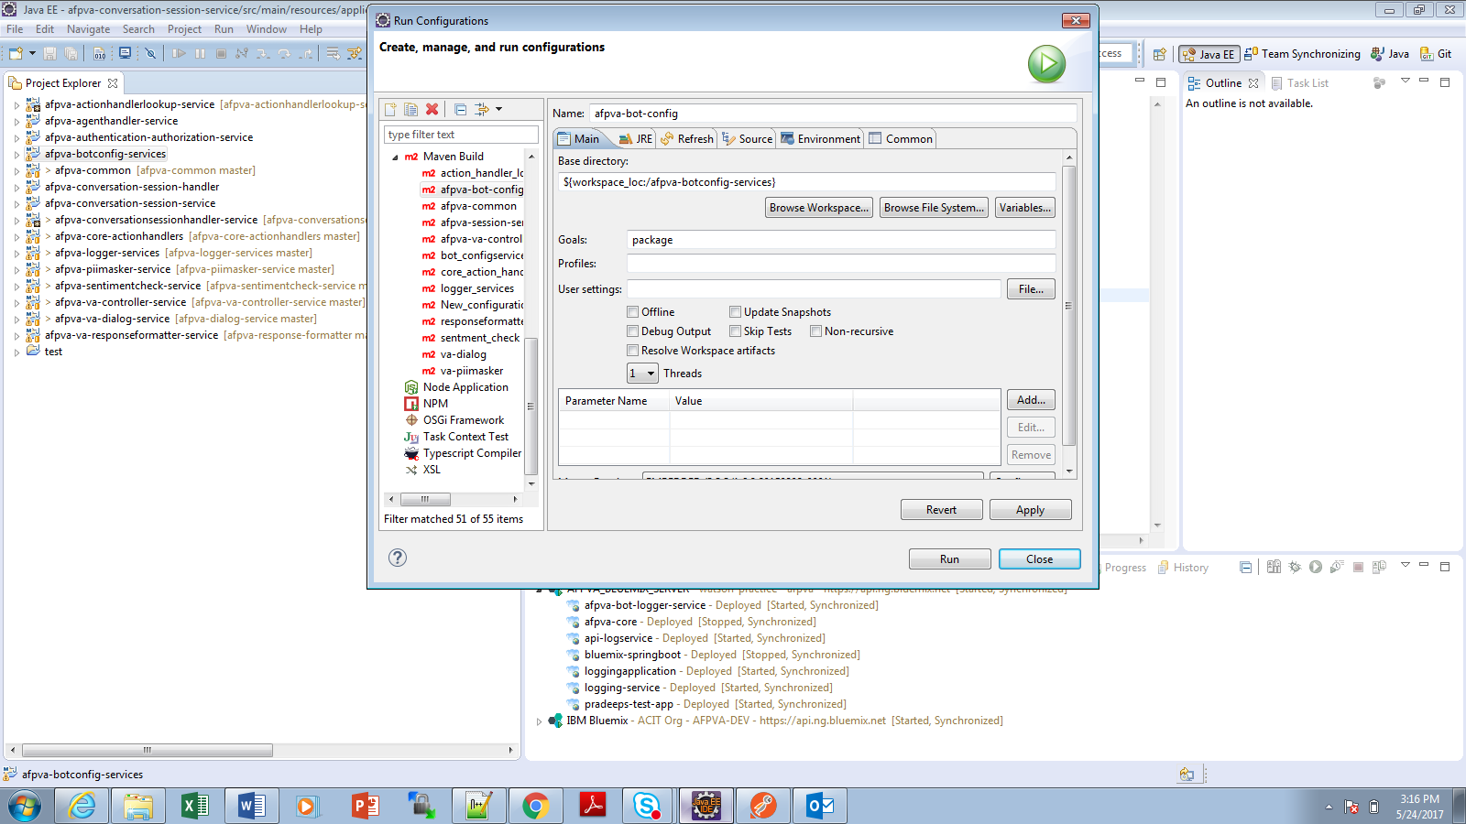

**Step 3:** Create Bluemix Server following below steps

1. Click on Servers -> New -> Server -> IBM -> IBM Bluemix and below scree appers

Provide server name (Its optional) and click next

<If you do not see IBM Bluemix option, please click here to install>

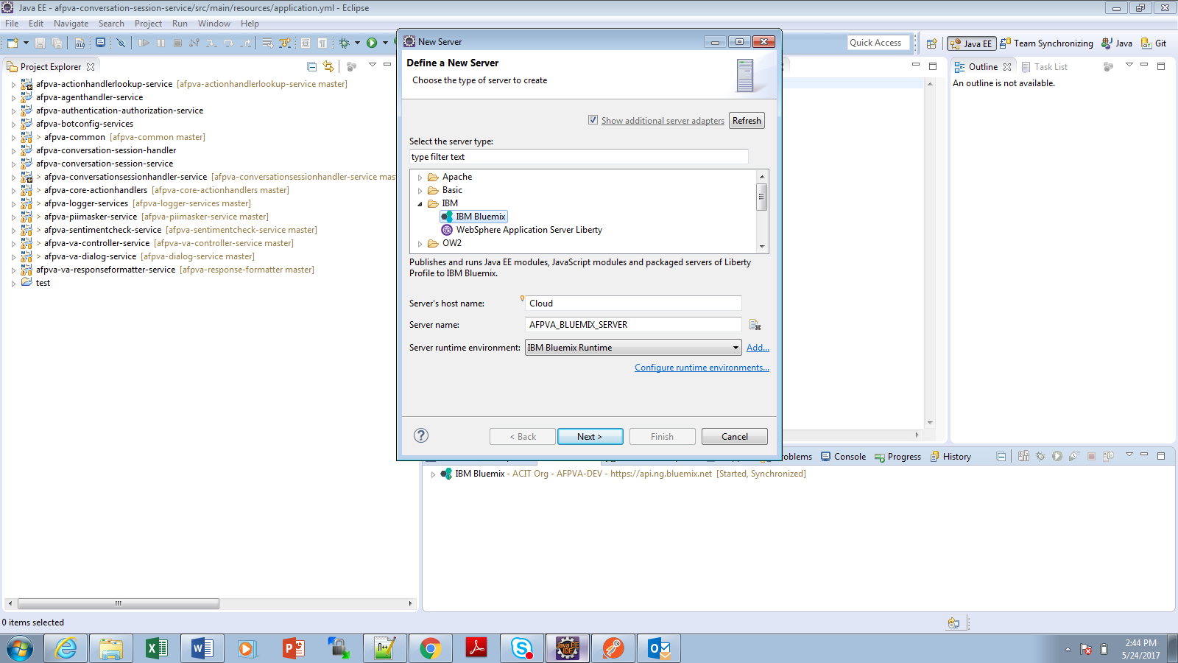

1. Provide Bluemix Login Account details and click on Validate. This will connect to bluemix server,validate login credentials and fetch all the Organizations and spaces that user got access. Finally Click Next

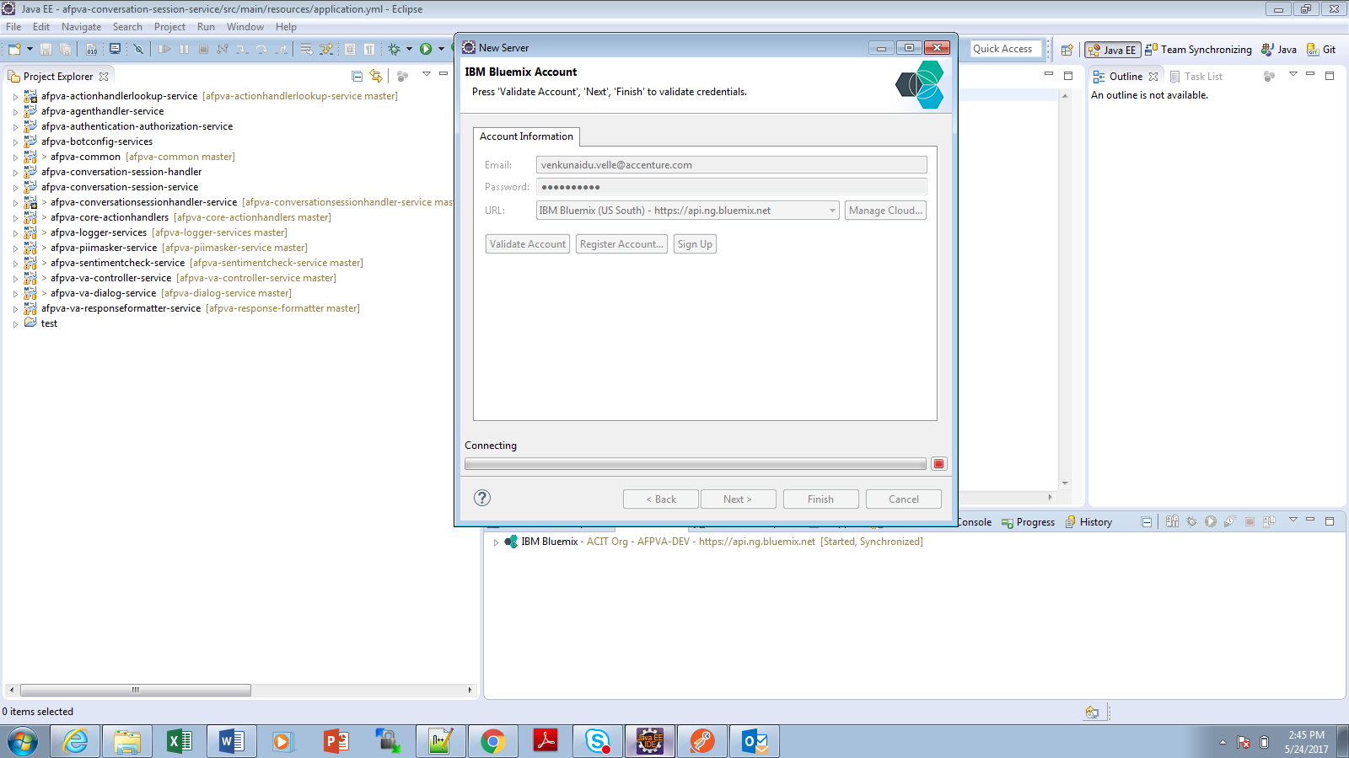

1. Selct the Bluemix Space and click finish . All deployments will happen on this space

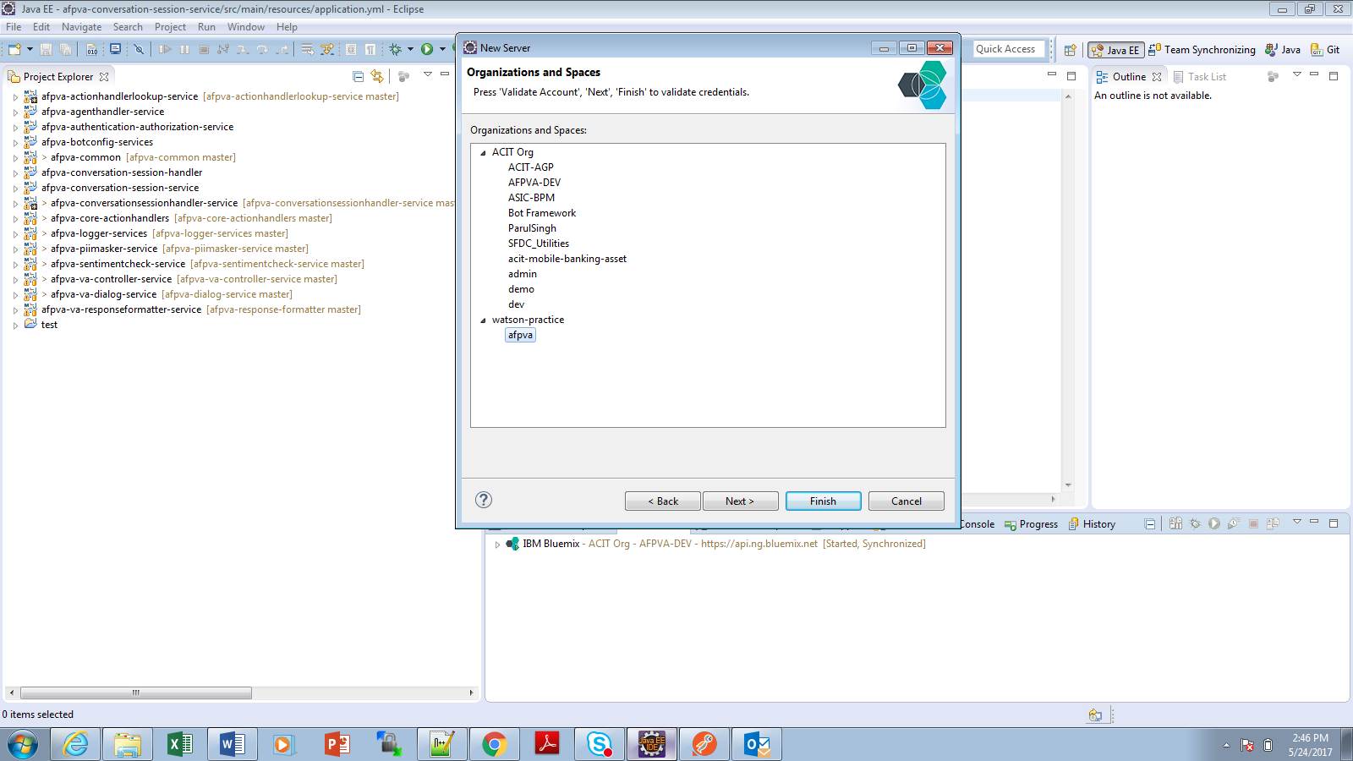

**Step 4:** Deploy (Add) Service to Bluemix server

1. Right click on Created Bluemix Server and click Add/Remove Option. This will show popup where we can add our build project modules to Server as shown below

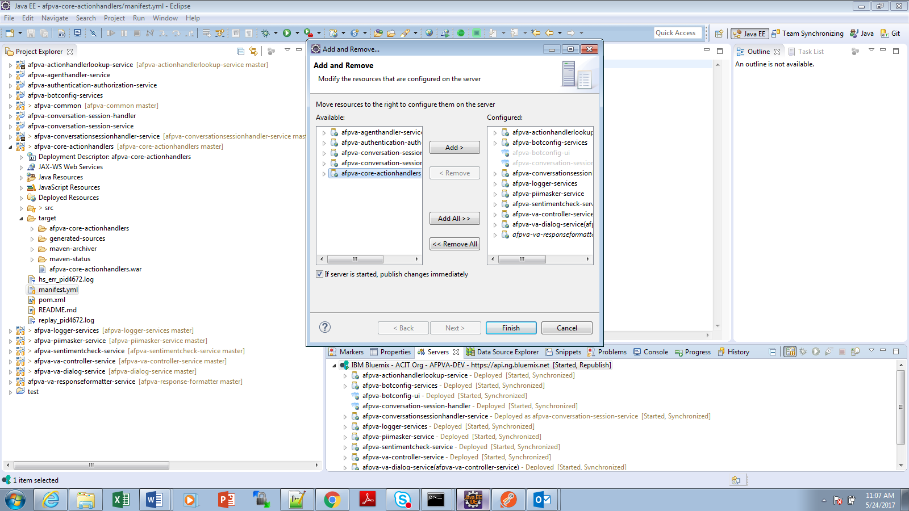

1. Select the project that we build in Step2 above and click option “Add>”. This will remove from left panel and get added to right panel as shown below. Finally click Finish

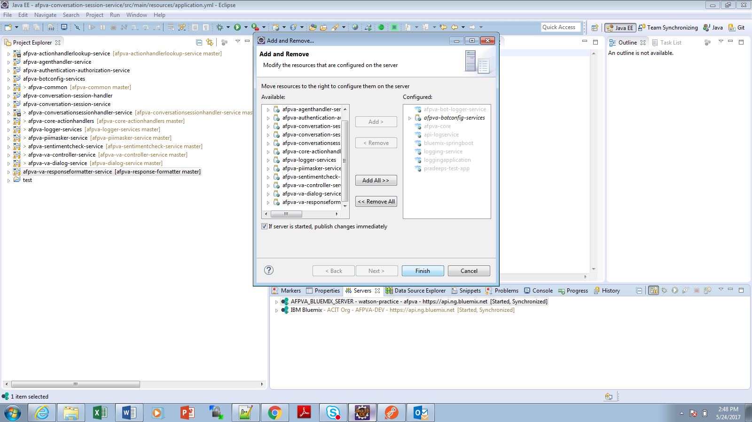

1. Application detail popup will appear and this will present series of screens for configuring

-Application Name on Bluemix

-Sundomain

-Deployed URL

-Memory

This basically read these details from the existing manifest.yml and present here. if we need we can change from here

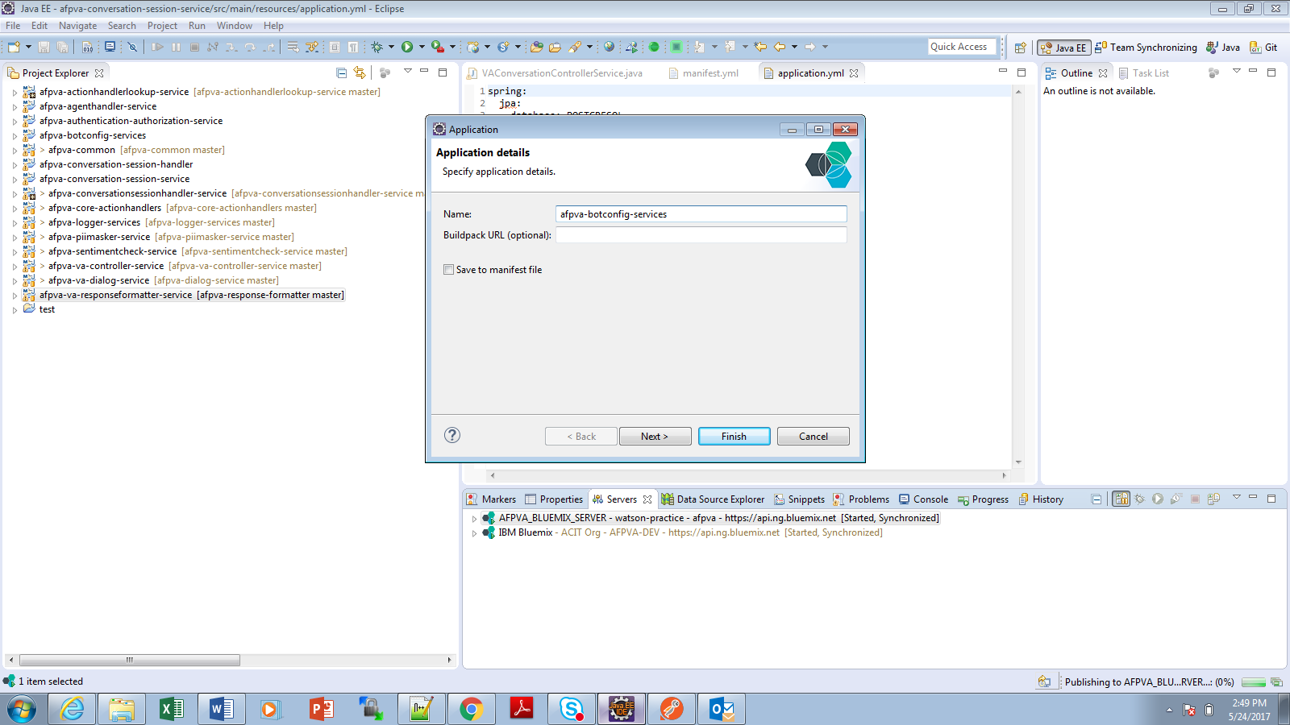

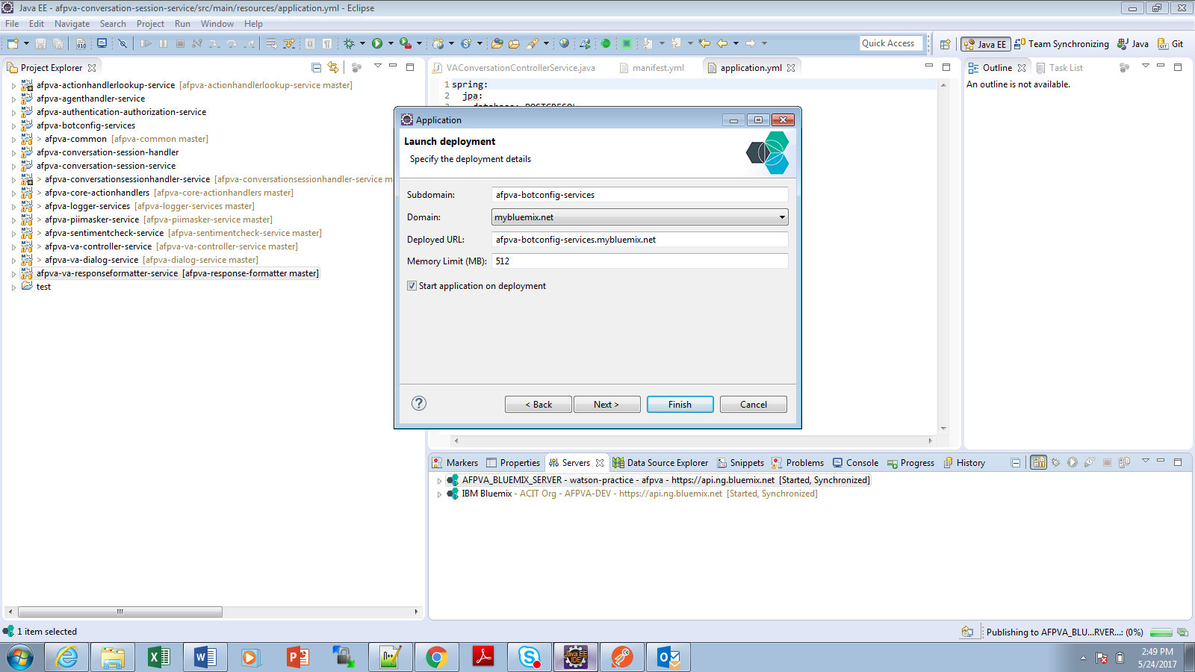

1. We can also bind any other existing bluemix services to our application and click Finish

*Here is an example how you can connect AFPVA services using Postgres DB and bind to application*



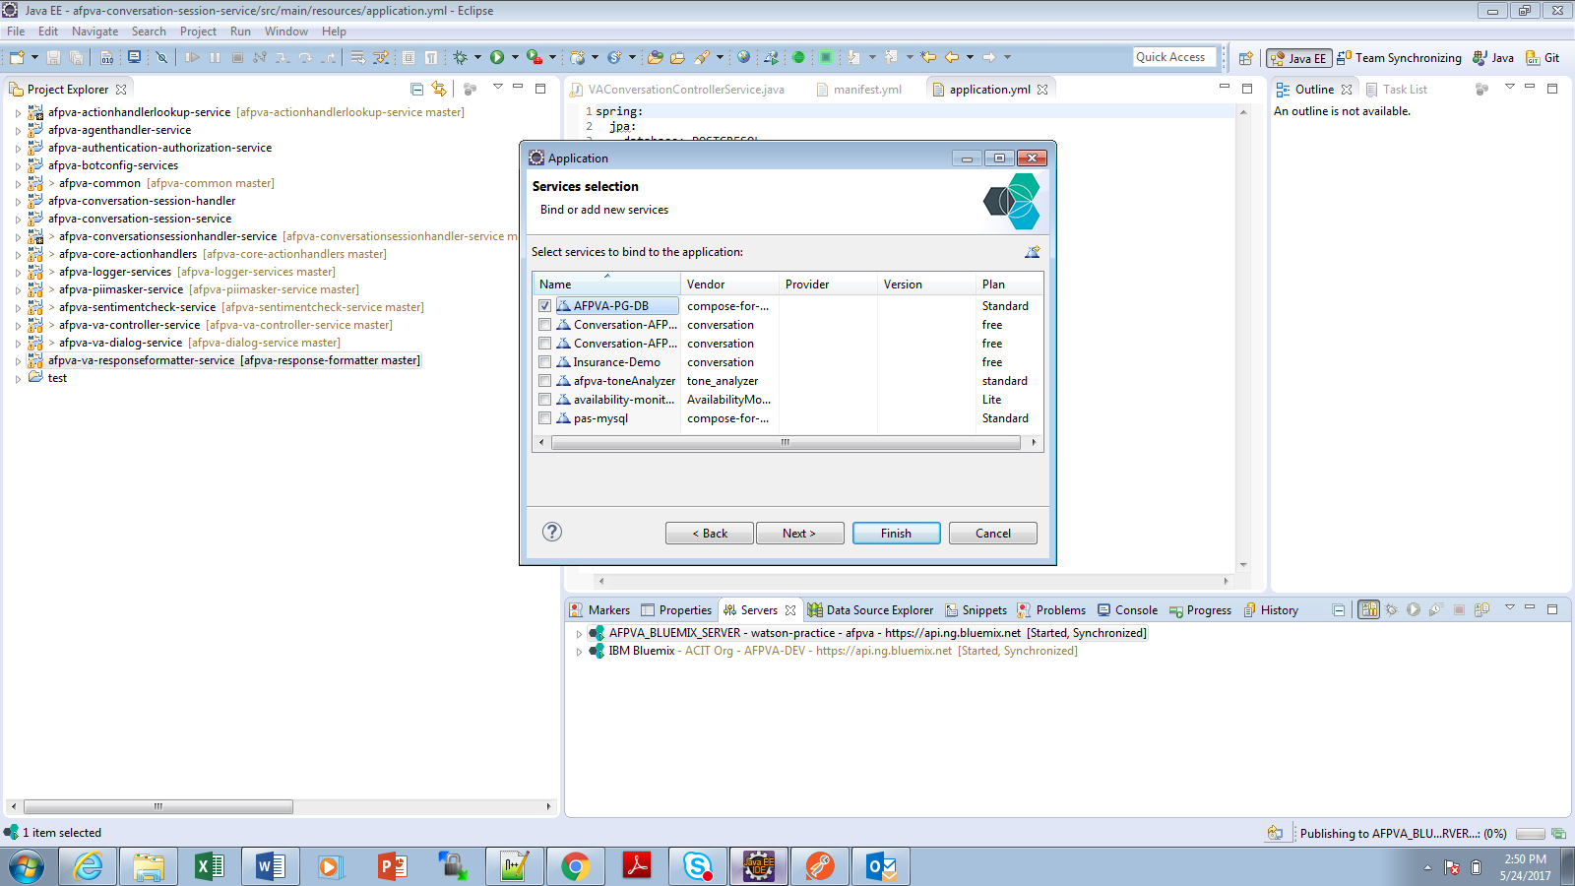

1. Application will be pushed, staged, deployed and started on bluemix now

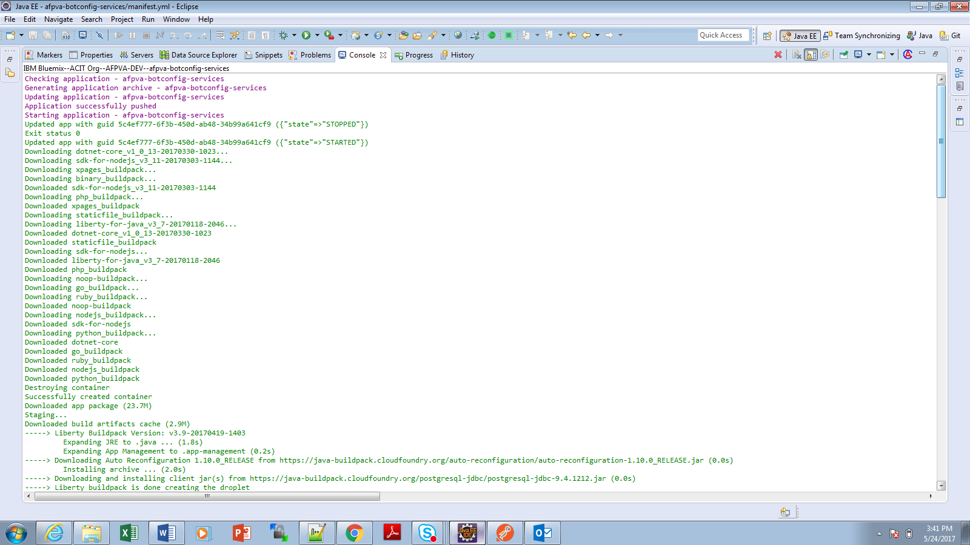

It need to perform all these steps for below AFPVA services

|  |  |  |  |
| --- | --- | --- | --- |
| **Inner Service Name** | **DB Required** | **Bluemix Service Name** | **Bluemix URL (Context URL)** |
| afpva-actionhandlerlookup-service | Yes | afpva-actionhandlerlookup-service | https://afpva-actionhandlerlookup-service.mybluemix.net/ |
| afpva-botconfig-services | Yes | afpva-botconfig-services | https://afpva-botconfig-services.mybluemix.net/ |
| afpva-conversationsessionhandler-service | Yes | afpva-conversation-session-service | https://afpva-conversation-session-service.mybluemix.net/ |
| afpva-core-actionhandlers | No | afpva-core-actionhandlers | https://afpva-core-actionhandlers.mybluemix.net/ |
| afpva-logger-services | Yes | afpva-logger-services | https://afpva-logger-services.mybluemix.net/ afpva-logger-services |
| afpva-piimasker-service | No | afpva-piimasker-service | https://afpva-piimasker-service.mybluemix.net/ |
| afpva-sentimentcheck-service | No | afpva-sentimentcheck-service | https://afpva-sentimentcheck-service.mybluemix.net/ |
| afpva-va-controller-service | No | afpva-va-controller-service | https://afpva-va-controller-service.mybluemix.net/ |
| afpva-dialog-service | No | afpva-dialog-service | https://afpva-va-dialog-service.mybluemix.net/ |
| afpva-response-formatter | No | afpva-response-formatter | https://afpvaresponseformatterservice.mybluemix.net/ afpva-responseformatter |
| afpva-connector | Yes | afpva-connecotr |  |

After successfully deploying all services mentioned above and if you login Bluemix then we will see the following list

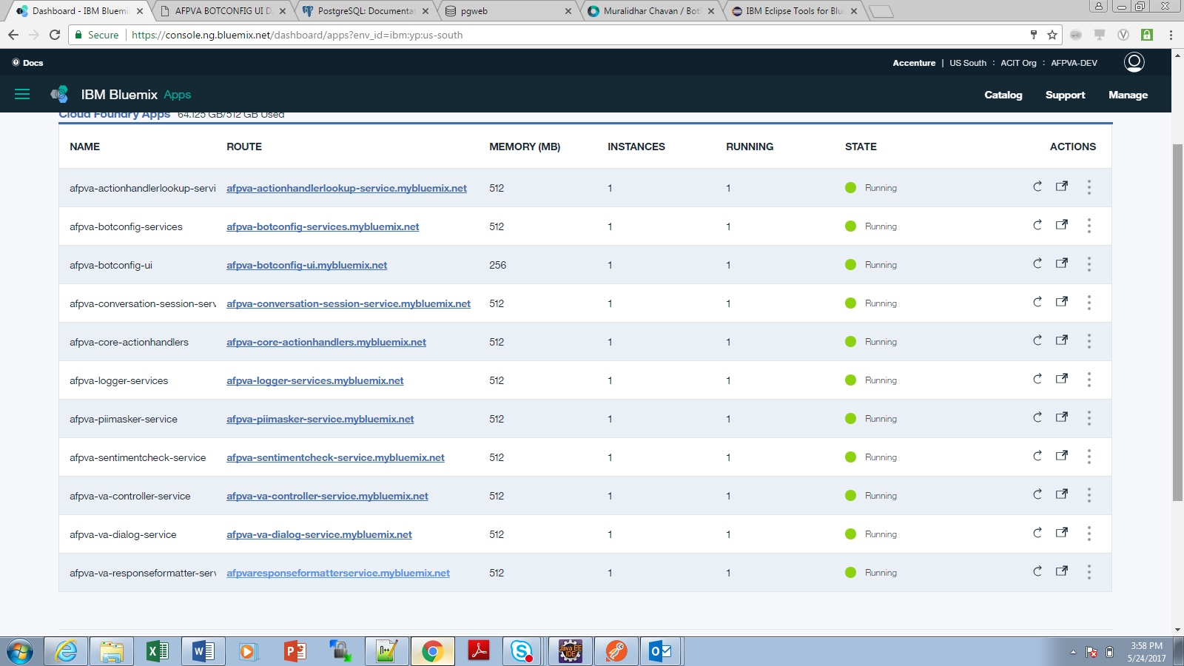

**Deploying afpva-agent-dashboard UI Application:**

Step1: Down load the code from Inner source using Link provided

Step2: Go to project folder and open configuration file “public\config\config.json” and modify the URLs with required URLS. Refer below screen shot for reference

*Note: If you keep and use default manifest.yml files shipped with below AFPVA services,*

*then this step can be ignored*

**afpva-actionhandlerlookup-service**

**afpva-botconfig-services**

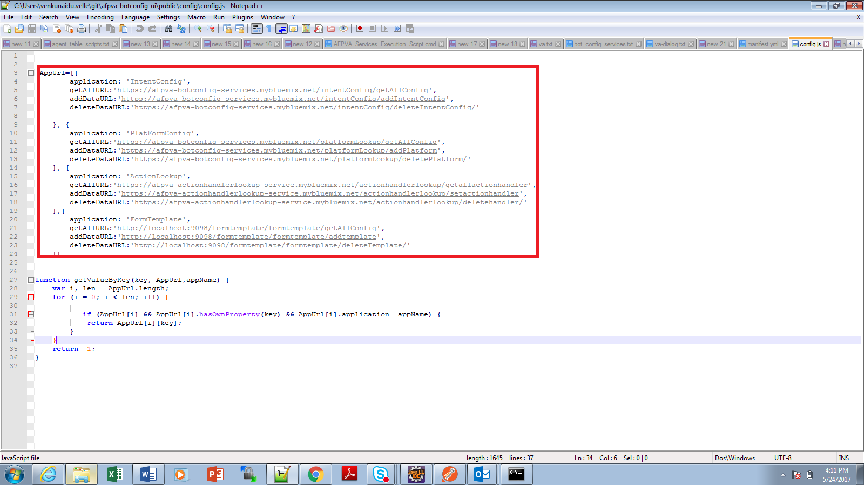

Step3: follow the steps as mentioned above for deploying this service on Bluemix

**Using Agent Dashboard UI for setting Configuration data:**

Bot config UI screens re used for managing following configuration

1. **Platform Lookup Configuration:**

This screen enable to configure various service REST endpoints into DB, which are need by Bot controller to dynamically invoke various AFPVA core services during execution

1. Launch UI Deployed Application using URL: <https://afpva-agent-dashboard.mybluemix.net/>
2. Access Settings -> “Platform Lookup Configuration” to add all AFPVA Platform service endpoints as shown below

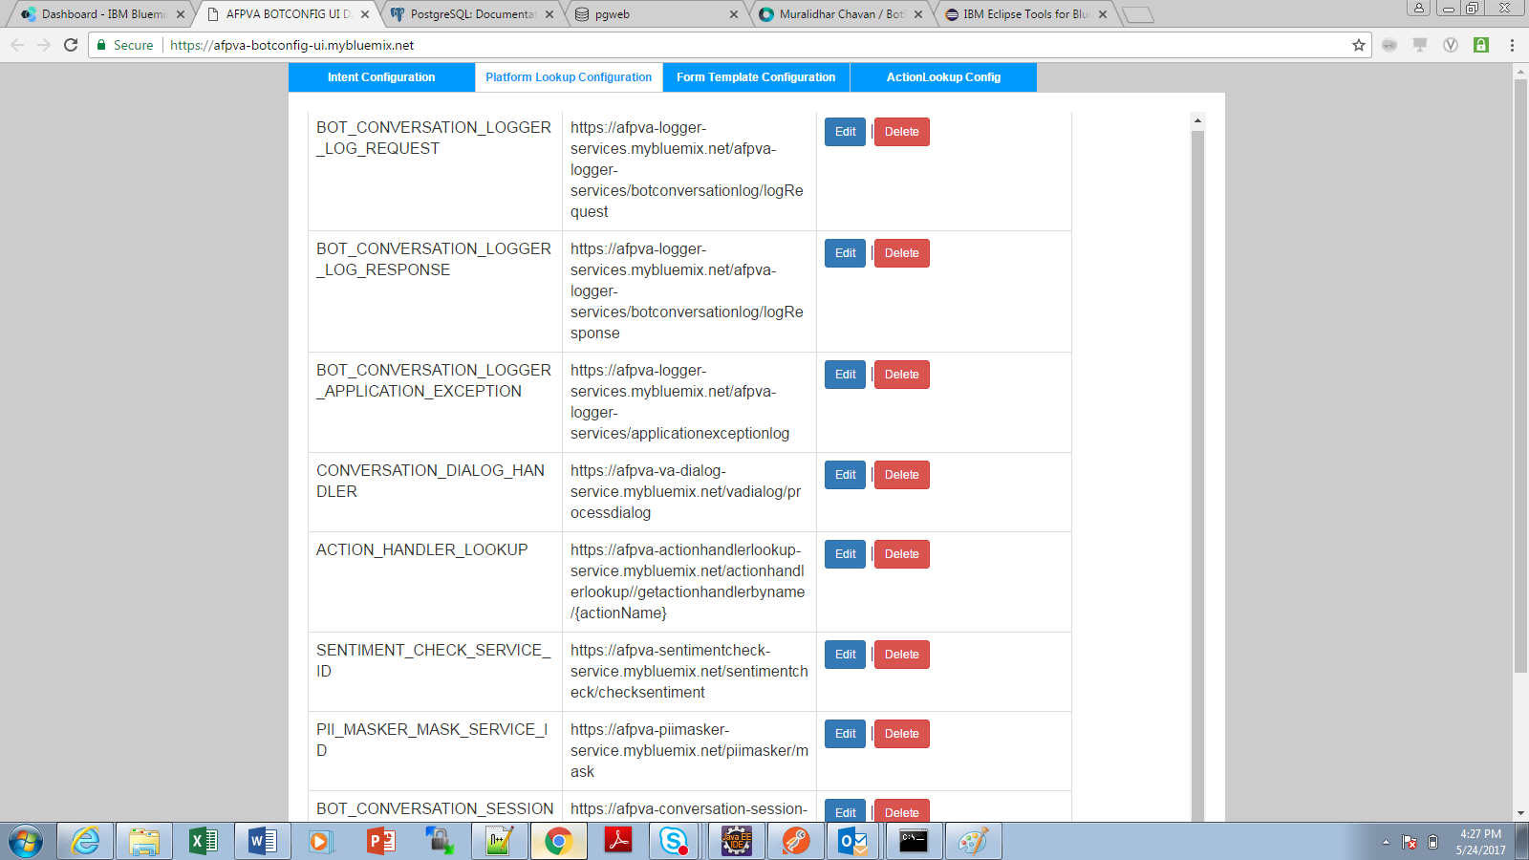

1. **Action Lookup Configuration:**

Use this screen for configuring core and business action handlers, which Bot Controller service use for performing certain action basing on action received from AI services

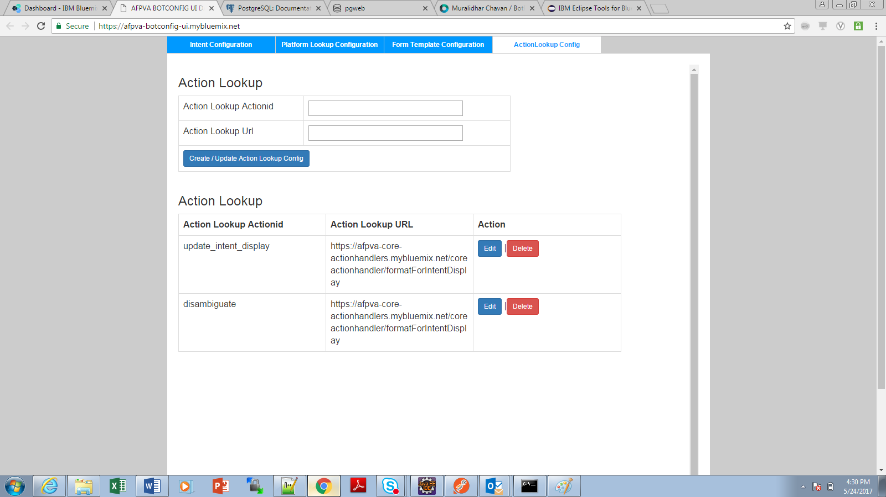

1. **Intent Configuration:**

Use this screen for configuring Intent configuration along with Work Space ID details

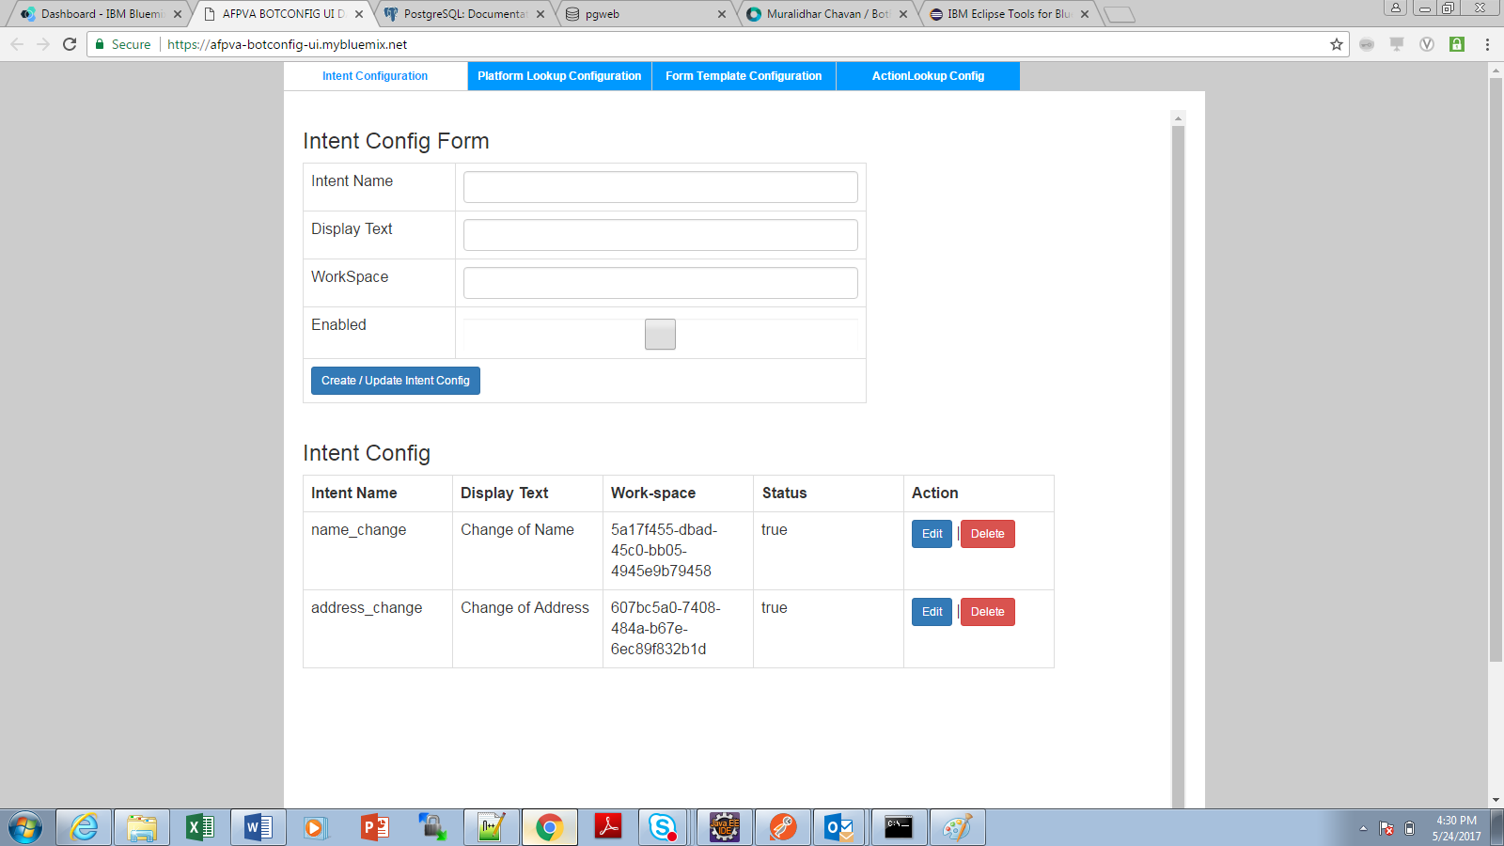

**Steps to install Bluemix in Eclipse**

* Open Eclipse
* Go to Help > Eclipse Marketplace. Search for ‘Bluemix’

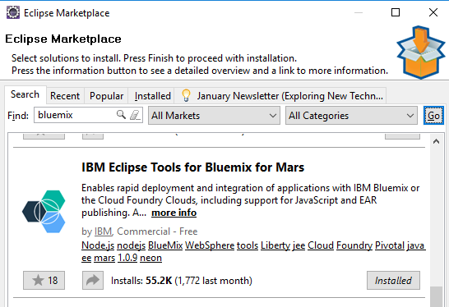

* Select the ‘IBM Eclipse Tools for Bluemix’ entry and click **Install**.
* By default, there are features selected for you. Click **Confirm**.
* Accept the license agreement and click **Finish**.